PHIL 2505 Overheads for Lec 5
10/13/2007
------------------------

Self-supported statements Are of two kinds

- Self-reports

- “I have a headache this evening.”
- “I believe the Earth is flat.”

- Analytic statements (or propositions)
Of two kinds

- Those that are true by virtue of their logical structure
- Either it is raining or it is not raining.
- If some sisters are women, then some women are sisters.

(called syntactically analytic statements)

- Those that are true by virtue of the definitions of the words they contain

- All sisters are women (true)
- All bachelors are men (true)

(called semantically analytic statements)
---------------------------------
Statements which are not self-supported are called contingent or synthetic propositions

- The lights are on in this room.
- There are seventeen trees in the college square at Yale University
- Dr. Marshall is the first president of Nipissing University.

Their truth must be ascertained by other means…
------------------------------------------
Telling the difference …

Semantically or syntactically analytic?
Or synthetic?

The moon revolves around the earth.

She’ll either be late or not late.

All actresses are women.

No males are females.

John A. Macdonald was the first prime minister of Canada.

The earth is flat.

Some humans are blind persons.

If some men are over six feet tall, then some things which are over six feet tall are men.

All spiders are creatures with eight legs.
----------------------------------

- Denotation – dictionary definition
- Connotation – dictionary definition plus emotional baggage – all the things we connect with the word

-------------------------------

All people who read novels are library users. Paul does not read novels. Therefore, Paul is not a library user.

All husbands are married people. No wives are husbands. Therefore, no wives are married people.

Buses use more gas than cars, so the city cannot reduce air pollution by buying more buses.

The MP’s argument in favour of legalizing marijuana should be ignored since he has confessed to using it in his youth.

------------------------------
Plato’s Theory of Knowledge

Justified True Belief

----------------------------------

Definition: Relativism

The belief that knowledge is determined by specific qualities of the observer, including age, race, gender, cultural conditioning, socio-economic bracket etc.

Moral Relativism:

The idea that what is moral behaviour in one society or for one person may not be moral behaviour in another society or for another person. Also that any particular statement about morality may not apply equally in all societies or for all people.

-------------------------------------

The truth of beliefs depends on the way the world is, not on the existence or strength of the beliefs

---------------------------------------
For those who believe, no proof is necessary.
For those who don’t believe no proof is possible.
John and Lynn St. Clair Thomas
in Eyes of the Beholder
------------------------------------------------------
p. 59

5 key things to think about in evaluating the observations that evidence is based on

- Physical conditions under which the observations were made
- The sensory acuity of the observer
- The necessary background knowledge of the observer
- The objectivity of the observer
- The supporting testimony of other observers

--------------------------

Conclusive evidence is, by definition, evidence so strong that it can never lead to false beliefs

But that’s often hard to come by…

Many things seem conclusive when they are not.

Life requires action – can’t always wait for conclusive evidence

-----------------------------------
Belief should be proportional to the evidence

- Weak evidence should lead only to weak belief

- Strong evidence warrants strong belief

This is the Principle of Proportional Belief

----------------------------------
The truth value of a proposition is not relative.

It cannot be true for you , but not true for me.

A belief can, however, be rational for you but not for me.

Or be rational today, but irrational tomorrow (when more evidence is available to me)

---------------------------------------

Larry Kramer (to whom I always give the time of day because, even when he's wrong, he writes so well) wrote that….

Larry Kramer replied:

I thank Ursula for her kind words about my writing, in which she demonstrates how we all make decisions on insufficient evidence. Ursula says I write well when I am wrong, but I do not know how she could have enough samples to support such an inference. Perhaps she is wrong about whether I am wrong, but if that is the case, maybe she's wrong about the writing, too. And yet, somehow I want to believe
her....

---------------------------------------

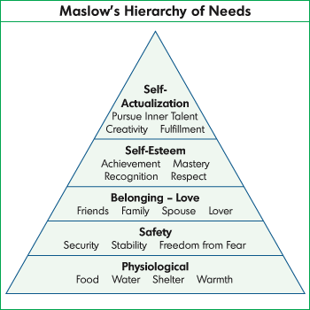

--------------------

" … in my first voyage from Boston, being becalmed off Block Island, our people set about catching cod, and hauled up a great many. Hitherto, I had stuck to my resolution of not eating animal food, and on this occasion I considered the taking of every fish as a kind of unprovoked murder, since none of them had, or could, do us any injury that might justify the slaughter.

"All this seemed very reasonable. But I had formerly been a great lover of fish, and, when this came hot out of the frying pan it smelt admirably well. I balanced some time between principle and inclination, till I recollected that, when the fish were opened, I saw smaller fish taken out of their stomachs; then, thought I, 'If you eat one another, I do not see why we may not eat you.' So I dined upon cod very heartily, and continued to eat with other people, returning, only now and then, occasionally to a vegetarian diet. So convenient a thing is it to be a reasonable creature, since it enables one to find or make a reason for everything one has a mind to do."

--------------------------------
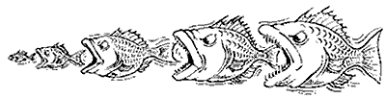

Fish eat other fish

----------------------
Therefore, humans can eat fish

What is the missing premise?

Are both premises true?

Is it valid?

Is the argument sound?

